**USING RAPTOR – SWAP TWO CHARECTERS**

**A.V Bhargava(191911110 )**

**FLOWCHART**

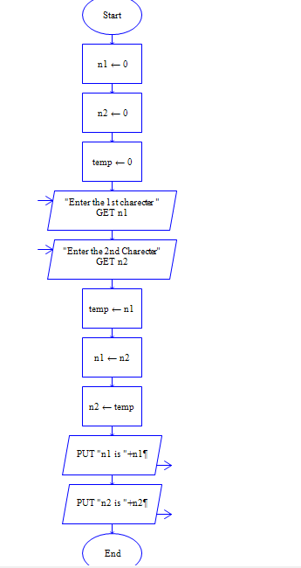

**OUTPUT**

INPUT

N1 =V

N2 = R

